**Learning from award-winning websites**

# Minus99 - Good UX/UI Practices

## 1.Typegraphy - Font spacing and line spacing

Their designer make best of typography by choosing appropriate font for the web.

For example in the figure 1 the font itself is extremely easy to read furthermore color between font and background provide good color contrast and make the text eye-catching in this section.



Figure 1

## 2. Visual Hierarchy

In the figure 2 designer and web devs make use of visual hierarchy i.e. make brand link be interactive frame that can animate and link to desire page/section to archive business goals.

Size can be use emphasize the importance of element in the website in this case that element is large frame that contain proudly presented brand by their company/website.

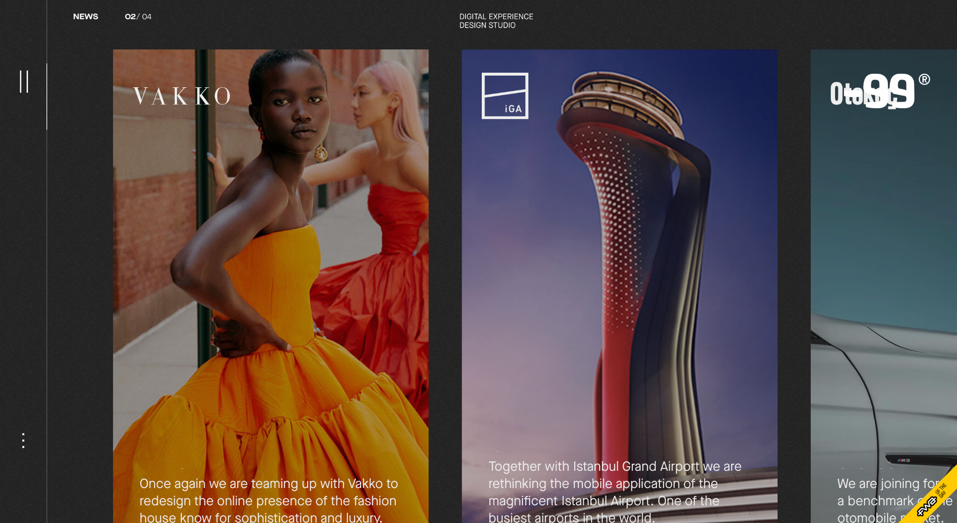

Figure 2

The Teacher Guild

## 1.Simple and Consistent

The Teacher Guild website make web element with everyone’s familiar design i.e. make nav-bar on the top of website, drop down element so everyone can interact with the website without any hesitation of new experience with new web. On the figure 3 you can see pretty familiar experience.

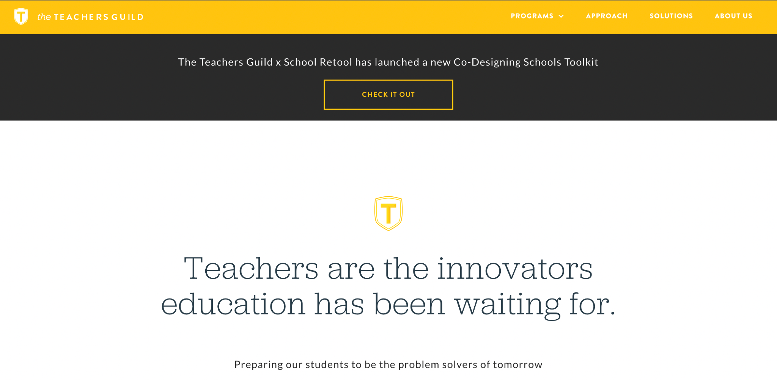

Figure 3

## 2.Make use of pictures/icon for visual telling

Basically if you can replace text with picture/icon you can make user understand more about your content and it can make your web more user friendly because user tend to not reading a lot of text (unless some site like novel site or programming documentation site). In the figure 4 I also like how they spacing each text evenly and beautifly.

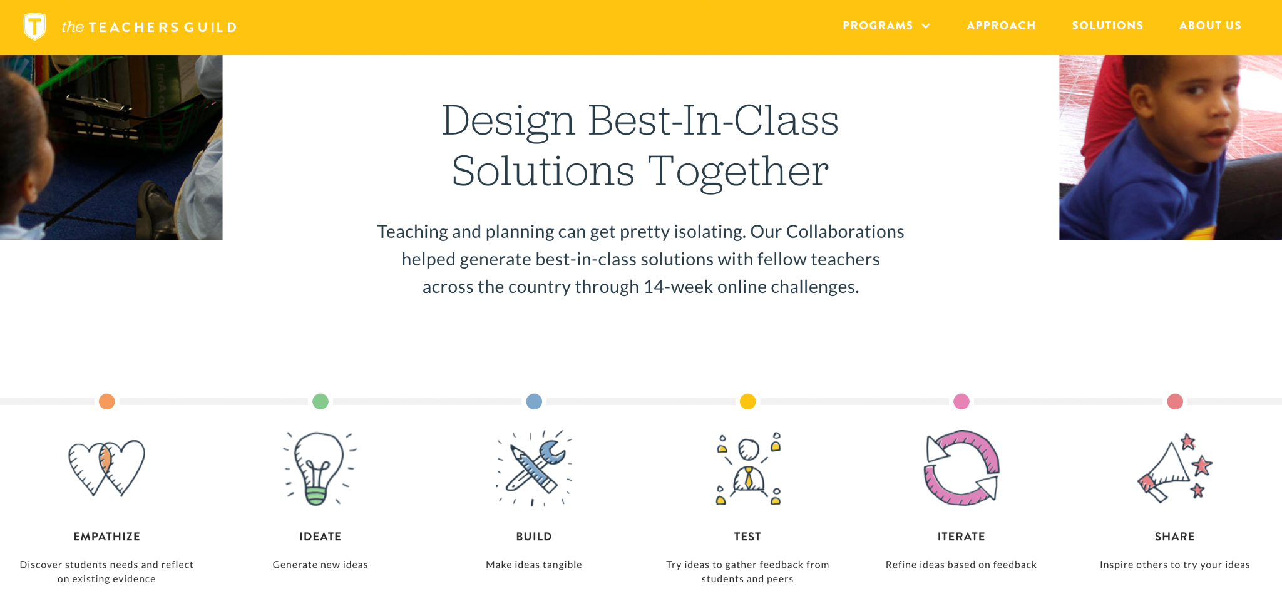

Figure 4